St Mary’s RC Primary School,

a Voluntary Academy





Pedagogy Policy 2023 - 24

Full of grace, we grow and learn together

Approved by: |  | Date: March 2024
Last reviewed on: | March 2024
Next review due by: | March 2025

Contents
- Aims
- Principles & Philosophy
- Legislation & Guidance
- Procedures & Practice
- Roles & Responsibilities
- Monitoring Arrangements
- Links with other policies
- Appendices
Aims
At St. Joseph’s our pedagogical approach aims to foster a curiosity and love of learning. We want children to know more and remember more so that each stage of new learning builds on solid foundations of knowledge, skills and concepts. We aim to guide children towards independence and success through presenting learning in small steps and well scaffolded models. By the end of each unit we want our children to be able to articulate their learning with increasing clarity and confidence, presenting their understanding of the joy, depth and importance of the content.

Principles and Philosophy

At St. Joseph’s our pedagogical approach is shaped by Rosenshine’s Principles of Instruction and our own unique structure ‘Do it’, ‘Twist it’, Deepen it’. Both are based on educational research and are proven to be highly effective.

Rosenshine’s Principles of Instruction
Rosenshine’s principles of instruction come from research into:
- Cognitive science and how the brain acquires and uses new information
- Classroom practice and instructional procedures used by the most successful teachers
- Cognitive Scientists and procedures invented to help students learn difficult tasks.

The principles can be organised into four strands:

Sequencing concepts and modelling
  - Present new material using small steps
  - Provide models
  - Provide scaffolds for difficult tasks

Questioning

  - Ask questions to allow children to explain the concepts being learnt
  - Check for student understanding

Reviewing Material
  - Daily review
  - Weekly and monthly review.

Stages of practice
  - Guide student practice
  - Obtain a high success rate
  - Independent practice

Rosenshine’s research based principles of instruction are evident in all of our teaching sessions and are used to craft, well-structured lessons to maximise learning and have impact on pupil outcomes. How the principles are used varies, as the strands take on different forms depending on the subject.

‘Do it, Twist it, Deepen it’
The approach is made up of three components that we call: ‘Do it, Twist it, Deepen it.’ During the ‘Do it’ part of the lesson, children are presented with new concepts, knowledge and skills. During the ‘Twist it’ children are presented with Blodwyn, a fictional character, who often has a misconception. The children have to explain what Blodwyn has done wrong using their understanding, and help her to correct her misconception. In the ‘Deepen it’ part of the lesson, learning is applied to a new context and in the process, concepts, knowledge and skills are deepened and secured. This structure is used in history, geography, science and RE and is also used in some maths sessions as it clearly provides evidence of mastery.

Peer Review.
At St Joseph’s there is a strong commitment to professional development. Our aim is to grow reflective, responsive practitioners, curious about the craft of teaching and learning. To support this, we use Peer Review to develop a teaching community that is also a supportive learning community. The focus for the Peer Review sessions can be on aspects of our pedagogical approach so that teachers deepen their understanding as to the effectiveness of the different aspects and how that looks in a classroom session.

Legislation & Guidance
Provision at St. Joseph’s Catholic Primary School, follows the requirements of the National Curriculum, set out by the Department of Education, 2014.

Guidance that has shaped Pedagogy at St. Josephs:
Education Endowment Fund ‘Teacher Feedback To Improve Pupil Learning’
Education Endowment Fund ‘Metacognition and Self-Regulation in Learning’
Sutton Trust Guidance
‘Rosenshine Principles in Action’ Tom Sherringham.

Procedures & Practice:
- ‘Do it, Twist it, Deepen it’ is the structure followed in History, Geography, Science, RE and Maths. The Rosenshine Principles fit into this structure as detailed in the table below.

- During the ‘Do it’ children are presented with the new concepts, knowledge and skills and they explore these in a variety of ways such as having examples modelled, using prompts to scaffold their own practice and working collaboratively. In the ‘Twist it’ part of the lesson, a fictional character Blodwyn presents a misconcept and the children have to help her by using their learning from the lesson. In the ‘Deepen it’ learning is applied to another context so the children can demonstrate a deeper level of understanding of the concepts, knowledge and skills.

Rosenshine’s Principles of Instruction applied in
‘Do it / Twist it / Deepen it’


Structure

Do it
Steps within the lesson
Daily/Weekly/Termly review

Present new material in small steps (cognitive load)

Questioning (WWW)

Provide models

Scaffold

Guided student practice
Examples
- Recap on previous learning & talk about how this learning links to this session.
- Use whole school timelines
- Daily practice of vocabulary, key facts
- Avoid brain overload / dismiss irrelevant material / Just focus on what pupils need to know
- Use ‘think aloud method’ (explaining
your own small steps of thinking
- Give LOTS of examples
- Involve every pupil with WWW
- Allow pupils to discuss with partners / groups (mixed ability)
- Example questions: what makes you say that? Is there another way you could say that ? what links those ideas together ? What evidence is there to support that ? How does your answer compare t..? What is the reason for that ? How is it connected to the first part / yesterday’s lesson/last week’s lesson? What would eth opposite of that be ? is that always true or just in this example?
- Work out examples / partially completed examples / Give prompts
- Use visuals / practical apparatus
- Think aloud going through your model
- Think aloud & show this with prompts (checklists, writing frames, WWW)
- Vary the level of scaffold according to pupil need.
- Aim to remove the scaffold so it is not a crutch.
- Repetition leads to fluency.

- Once pupils have knowledge they have to keep rehearsing it through summarising, evaluating, or applying this knowledge
- If you rush this process, then students’
memory on lesson material will be diminished.
 |  | Provide misconceptions  & ask for explanations / solutions | - For the Do it part of the lesson, do this  verbally ‘what if…?’ ‘ How could…?’  - Ensure pupils are using appropriate vocabulary when answering these  verbally (if they cannot say it, they will not write it)
 |  | Independent Practice  (5 and fly) | - Involve same type of material that has  been presented / questioned about/ modelled / scaffolded  - For the ‘Do it’ part of the lesson this is just to become fluent pupils do not need to spend too long on this (5 and fly). Once they understand; move on  - Go round and supervise their seat work (use of TA)
 | Twist it    Blodwyn | Check understanding | - This can be done by asking students to summarise the information, asking questions about the material, what their opinion is, or asking them to make a presentation.  - WWW  - Enables you to address any misconceptions and misunderstandings
 |  | Questioning | - Involve every pupil with WWW  - Allow pupils to discuss with partners / groups (mixed ability)  - Ensure that verbal answers are using appropriate vocabulary in their  response
 |  | Scaffold | - Think aloud & show your process with  prompts (checklists, writing frames, WWW)  - Write prompt questions on the board for pupils to answer a misconception  - Have key words (vocabulary) available for pupils to use in their responses  - Provide checklists/writing frames
 |  | MORE independent  practice (misconception  ‘Blodwyn’) | - What it is / what it is not  - Encourage pupils to reconstruct and internalise the knowledge they have from the ‘Do it’ part of the lesson  - Give pupils conceptual generalisations to reason through why they may not be  correct
 |  | Obtain high success  rate | - 80% success rate – if pupils are getting  too much wrong then they are practising errors  - Go round and observe seat work / use TA / question constantly WWW

 | Deepen it | Questioning | - Example questions: what makes you say that? Is there another way you could say that ? what links those ideas together ? What evidence is there to support that ? How does your answer compare t..? What is the reason for that ? How is it connected to the first part / yesterday’s lesson/last week’s lesson? What would eth opposite of that be ? is that always true or just in this example? But in response to pupils work/learning from the Deepen it part  of the lesson specifically
 | Deepen it | Further scaffolding for deepen it task (if required) | - The deepen it tasks may be very different to previous ‘Do it’ or misconceptions so new checklists, prompts, reminders, writing frames  may be required
 | Deepen it | Check again for  understanding | - This can be done by asking students to  summarise the information, asking questions about the material, what their opinion is, or asking them to make a presentation.  - Ask other pupils to respond to a pupils summary/answer etc WWW  - Enables you to address any misconceptions and misunderstandings for Keep up not Catch up with the TA  that afternoon/following morning
 | Deepen it | High success rate | - 80% success rate – if pupils are getting  too much wrong then they are practising errors  - Go round and observe work / use TA / question constantly WWW
 | Deepen it | Daily / Weekly /  monthly review | - Ensure pupils do not go away without  linking what they have learned today with previous learning  - So important that this IS NOT JUST A  REMINDER and gives pupils the chance to link ideas together.
- All other subjects that do not use the Do it, Twist it, Deepen it structure use Rosenshine’s principles, presenting learning in small steps and applying the pedagoagical approach to the subject content, as can be seen, for example, in Music, Art and Spanish.

- Teachers all use a range of questions to encourage the children to remember previous learning, explain the new learning and reason and justify their answers. The 3 core questions are presented as WWW
Who else agrees? Why?
What else could it be?
Teachers naturally expand on this for answers to be developed more fully:
Prove it.
Who can add to what X has said?’
Can you explain so that all understand? Can you explain using some of the vocabulary you have learned today?


What makes you say that? How is that connected to….? Is that always
true?

- Sentence stems and subject vocabulary are displayed in classrooms and these are used when teaches are modelling learning. Children use them as a scaffold for their own answers as they move from practice to independence.

- Memory Walls are in all classrooms and this is used for recap and review of previous learning, so children can link new ideas to what has gone before.

- Foundation subjects use Knowledge Organisers which are referred to at the start of each unit and then, as learning is explored, they are a useful reference point for key knowledge, concepts and skills.

- Flashback sessions happen weekly. During this time, subjects on the Memory Wall are discussed, summarised, recapped and reviewed. The aim of this session is to keep learning fresh in the children’s minds and move key content from working memory into long term memory. This has been shown to reduce the cognitive load as new learning is added.

- The student:teacher input into each part of the lesson at St Joseph’s is
exemplified in this model from Education Endowment Fund.

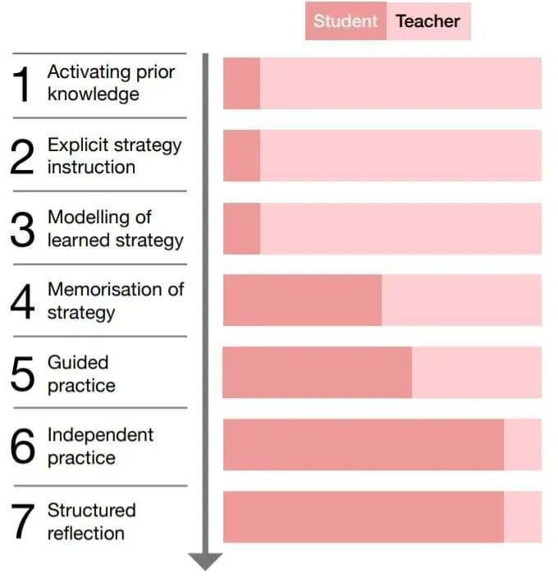

SEN Provision

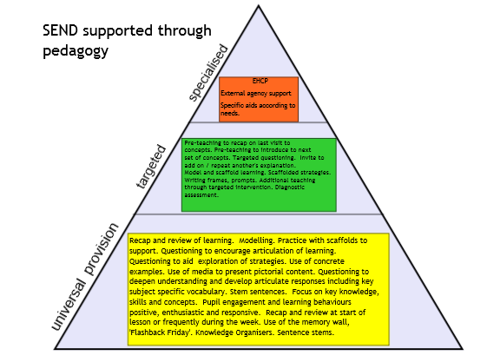

Roles & Responsibilities

Effective Pedagogy is the responsibility of the Assistant Head Teacher lead for pedagogy, each subject lead, the SLT and the classroom teachers.

Subject Leads:
- Offer support to all members of staff in the planning, teaching and assessment of their subject to effectively incorporate Rosenshine’s Principles of Instruction.
- Provide opportunities for colleagues to observe good practice in the teaching of their subject with a focus on the elements of effective pedagogy.
- Monitor classroom teaching and learning and be able to summarise pedagogy in their subjects.
- Monitor assessment of their subjects to inform effectiveness of pedagogy being implemented.
- Lead and source staff training as necessary.
- Have enthusiasm for pedagogical approach in their subject and encourage staff to share this enthusiasm.
- Keep the AHT lead for pedagogy, Headteacher and governors informed on the consistency, implementation and effectiveness of pedagogy in school.

The Role of the Class Teacher:
Individual teachers are responsible for utilising the Rosenshine’s Principle of Instruction
in their class teaching.

The class teacher will:
- Secure pupil learning and engagement through well planned sessions, delivered
through Rosenshine’s Pedagogical approach.
- Provide a learning environment that supports knowing more, remembering more, including an up-to-date Memory Wall, Working Walls, sentence stems and key vocabulary for each subject displayed.
- Provide equality of opportunity through using a range of approaches, techniques and resources to enable all to access the learning.
- Plan effective questioning for recall of previous learning, explaining, reasoning, deepening learning and for assessment.
- Provide a range of tasks for children to learn
- Be reflective and responsive to the learners needs when using the pedagogy.
- Take part in peer review and other CPD with a positive attitude to reflect, develop and improve their own practice and that of colleagues.

Monitoring Arrangements
Monitoring in Pedagogy is the responsibility of the Pedagogy Lead (AHT), Subject leads and the SLT.

Pedagogy will be monitored in the following ways:
- Consultation with staff
- Consultation with pupils
- Work scrutiny
- Learning Walks
- Lesson observations
- Monitoring of formative and summative assessments
- Analysis of summative data

Actions for development will be given to class teachers, and a short report provided for the Headteacher/Governors.

It will also enable key areas of development to be identified, which will form the Pedagogy Action Plan which also feeds into Subject Lead Action Plans.

Links with other policies
Please refer to:
- All Subject policies
- Marking and Feedback Policy
- SEND Policy

4.
5.
6.
Monitoring and Evaluation Policy Remote Learning Policy
SMSC Policy

