St Mary’s RC Primary School,

a Voluntary Academy





Personal, Social, Health and Economic Education Policy

Full of grace, we grow and learn together

Approved by: | C Baron | Date: February 2024
Last reviewed on:
Next review due by: | February 2025

Contents
- Aims
- Principles & Philosophy
- Legislation & Guidance
- Procedures & Practice
- Roles & Responsibilities
- Monitoring Arrangements
- Links with other policies
- Appendices

Aims
Personal, social, health and economic (PSHE) education is an important and necessary part of all pupils’ education. Learning about healthy relationships, online harms, mental health and healthy lifestyles will equip children with the tools needed to develop resilience and become well rounded, healthy adults.
We believe and support the following educational aims in respect of Personal, Social, and Health Education. We teach the children ‘You must love the Lord your God with all your heart, with all your soul, with all your strength and with all your mind and love your
neighbour as yourself.’ Luke 10:27

Principles and Philosophy
Principles of teaching PSHE
- Start where children and young people are: find out what they already know, understand, are able to do and are able to say. For maximum impact involve them in the planning of your PSHE education programme.

- Plan a ‘spiral programme’ which introduces new and more challenging learning, while building on what has gone before, which reflects and meets the personal developmental needs of the children and young people.
- Take a positive approach which does not attempt to induce shock or guilt but focuses on what children and young people can do to keep themselves and others healthy and safe and to lead happy and fulfilling lives.

- Offer a wide variety of teaching and learning styles within PSHE education, with an emphasis on interactive learning and the teacher as facilitator.

- Provide information which is realistic and relevant and which reinforces positive social norms.

- Encourage young people to reflect on their learning and the progress they have made, and to transfer what they have learned to say and to do from one school subject to another, and from school to their lives in the wider community.

- Recognise that the PSHE education programme is just one part of what a school can do to help a child to develop the knowledge, skills, attitudes and understanding they need to fulfil their potential. Link the PSHE education programme to other whole school approaches, to pastoral support, and provide a setting where the responsible choice becomes the easy choice. Encourage staff, families and the wider community to get involved.
- Embed PSHE education within other efforts to ensure children and young people have positive relationships with adults, feel valued and where those who are most vulnerable are identified and supported.

- Provide opportunities for children and young people to make real decisions about their lives, to take part in activities which simulate adult choices and where they can demonstrate their ability to take responsibility for their decisions.

- Provide a safe and supportive learning environment where children and young people can develop the confidence to ask questions, challenge the information they are offered, draw on their own experience, express their views and opinions and put what they have learned into practice in their own lives.
Staff at St Josephs’ will teach:
•To raise pupils’ awareness about relationships – with themselves, with God and with each other,
  - To deepen understanding of what it means to love – themselves, God, family and each other,
  - To encourage pupils’ growth in self -respect, acknowledging we are all created in the image and likeness of God,
  - To raise students’ self-esteem and confidence, especially in their relationship with others.
•To develop skills in language, decision making and assertiveness.
  - To help pupils develop an understanding that love is the central basis of relationships,
  - To help pupils to understand the nature of relationships and to encourage them to reflect on their own relationships and respect differences between people,
  - To develop pupils’ confidence in talking, listening and thinking about feelings and
relationships,
  - To help pupils’ confidence in talking, listening and thinking about feelings and
relationships,
  - To help pupils acquire the skills necessary to develop and sustain relationships,
  - To ensure that pupils protect themselves and ask for help and support when needed,
  - To ensure that pupils are prepared for puberty
•To help pupils to develop a healthier, safer lifestyle.
•To help young people gain access to information and services.

•To enable children and young people to participate in society and value themselves and others.
•To develop confidence and responsibility and make the most of their abilities.
•To encourage children to prepare to play an active role as citizens and members of a
democratic society

Legislation & Guidance
We recognise the intrinsic link between PSHE, RSE and Keeping Children Safe in Education 2021 updates and have incorporated Paragraphs 117 & 118 (Keeping young people safe online; helping pupils to respect boundaries and act upon consent), Paragraph 121 (CPD for teaching staff), Paragraph 145 (Peer on Peer abuse) and Part 5 ( Incidents of sexual violence and abuse). We ensure age appropriate coverage is part of the curriculum and that coverage of the nine protected characteristics of the Equality Act 2020 are explored in an age appropriate manner as part of St Joseph’s statutory safeguarding obligation.

Personal, social, health and economic (PSHE) education is an important and necessary part of all pupils’ education. All schools should teach PSHE, drawing on good practice, and this expectation is outlined in the introduction to the proposed new national curriculum.

PSHE is a non-statutory subject. To allow teachers the flexibility to deliver high-quality PSHE we consider it unnecessary to provide new standardised frameworks or programmes of study. PSHE can encompass many areas of study. Teachers are best placed to understand the needs of their pupils and do not need additional central prescription.

However, while we believe that it is for schools to tailor their local PSHE programme to reflect the needs of their pupils, we expect schools to use their PSHE education programme to equip pupils with a sound understanding of risk and with the knowledge and skills necessary to make safe and informed decisions.

Schools should seek to use PSHE education to build, where appropriate, on the statutory content already outlined in the national curriculum, the basic school curriculum and in statutory guidance on: drug education, financial education, sex and relationship education (SRE) and the importance of physical activity and diet for a healthy lifestyle.

https://www.gov.uk/government/publications/personal-social-health-and-economic- education-pshe/personal-social-health-and-economic-pshe-education

Procedures & Practice
The PSHE programme used at St Mary’s is called: Talking Points.
It uses picture books as a starting point to get children talking about their own health and mental wellbeing as well as addressing other issues such as managing money and understanding democracy. Its aim is to develop children’s understanding of themselves, their emotions and how to deal with others. It also teaches children how to stay safe in many situations and who to speak to if they are ever worried or concerned.
Themes explored in this programme are:
Families and People who care for me Caring Friendships
Respectful Relationships Online Relationships Being Safe
Mental Wellbeing Internet Safety & Harms Physical Health & Fitness Healthy Eating
Drugs, Alcohol & Tobacco Basic First Aid
Health & Prevention Changing Adolescent Body

As with all aspects of learning, children are naturally curious and many will have questions related to their lessons. Opportunities to discuss questions form part of the lessons and again these are treated with care and understanding.
When teaching PSHE, it is important to create an environment where children:
    - Feel safe and secure
    - Develop the confidence to talk, listen and think about feelings and relationships
    - Make and maintain friendships
    - Develop positive attitudes about growing up
    - Explore their own and other people’s attitudes and values
    - Challenge and prevent discrimination
    - Use positive and encouraging language
    - Understand that opinions may differ but that this is natural
The PSHE programme will be delivered each week, where the pupils will focus on a particular book and concept and spend two weeks thinking, discussing, debating, analysing and reflecting on the particular idea before they move on to a new concept. The PSHE programme has been approved by staff, parents and endorsed by Governors. It is intended to act as a vehicle through which teachers and parents can help children to understand more fully the world they live in and their responsibilities as human beings.

Roles & Responsibilities

Role of the Subject Leaders
It is the responsibility of the subject leader to monitor the level of PSHE that is being taught throughout the curriculum. They have to ensure all staff have suitable training and support them in the delivery of some of the more sensitive topics.

It is the subject leader’s responsibility to either lead CPD training for staff or to procure it
from another source.

Role of Class Teacher
It is the role of the class teacher to deliver the specific units of work for their year group to the highest possible standard. Class teachers are responsible for ensuring that the children are comfortable when discussing some of the topics and ensure they follow up any concerns that may have been raised. Teachers will be expected to teach PSHE in accordance with the Catholic Ethos of the school. Appropriate training will be made available for all staff teaching PSHE.

All Staff
All teachers have a responsibility of care. As well as fostering academic progress, they should actively contribute to the physical, moral and spiritual well-being of pupils. The contents of this policy and the PSHE programmes will be shared with all staff so everyone is fully aware of their responsibilities.

Working with Parents
Under the Education Act 1996 pupils can be withdrawn by their parents from part of relationship and sex education that is outside the compulsory elements of sex education contained in the science national curriculum. Parents wanting to exercise this right are invited to see the Head teacher who will explore the concerns of parents and discuss any impact that withdrawal may have on the child. Following this discussion, if a parent still wishes to withdraw the child we would ask that the request be submitted in writing. Once a child has been withdrawn they cannot take part in relationship and sex education until the request for withdrawal has been removed. This will be reviewed with the parents each year.

Monitoring Arrangements
The PSHE Subject Lead will monitor the provision of the various dimensions of the programme by examining plans, schemes of work and samples of pupils work at regular
intervals and by having conversations with individuals. Pupils’ progress in learning in PSHE is assessed as part of the assessment of RE and Science. The programmes will be evaluated by discussion with pupils, staff and parents.

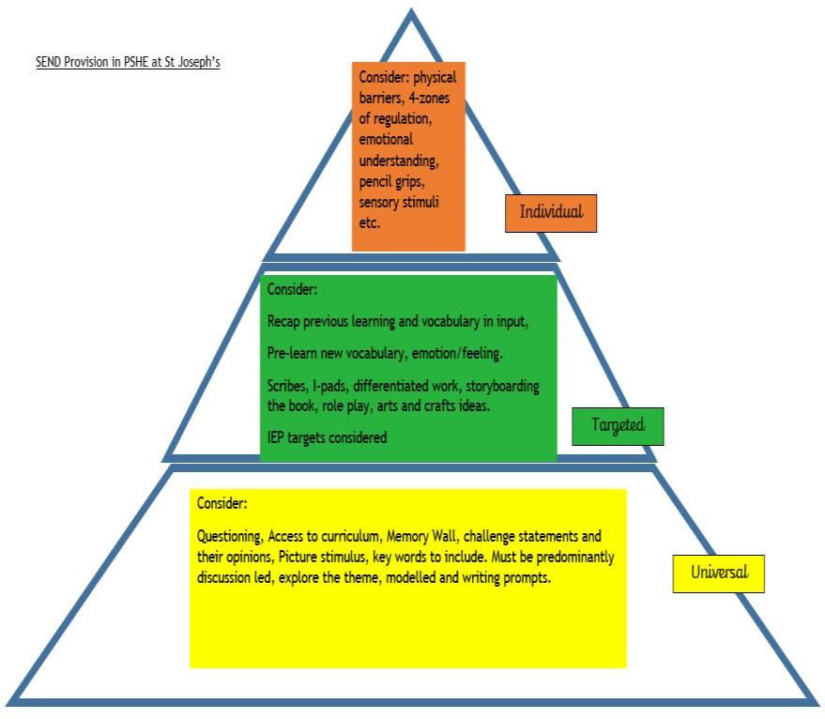
SEND within PSHE (see SEND policy for more details):

Links with other policies
Please refer to:
Relationships and Sex Education (A Journey in Love) Social and Emotional Learning
Broader Curriculum (SMSC integrated)
Religious Education (The Way, the Truth, the Life) Music (emotions)

